Compare significant SNP from different GAPIT models

Often, we run GAPIT with several models, so one question we want to know is if the same SNPs turn out significant in the different models.   
An application that takes GAPIT results of different models (usually of the same run) and plot the common significant SNPs for n models can be found at: <http://icci-2:9100/manhattan/>

How to use the application?

You need to be connected to the TAU network and have csv results files of GAPIT on your computer, in this example I used only 3 models out of the 5 possible.

Select how many models in common you want to get  
(here I choose to see only SNPs that were significant in at least 2 models)

Upload GAPIT results from your computer (wait to see ‘Upload complete’)

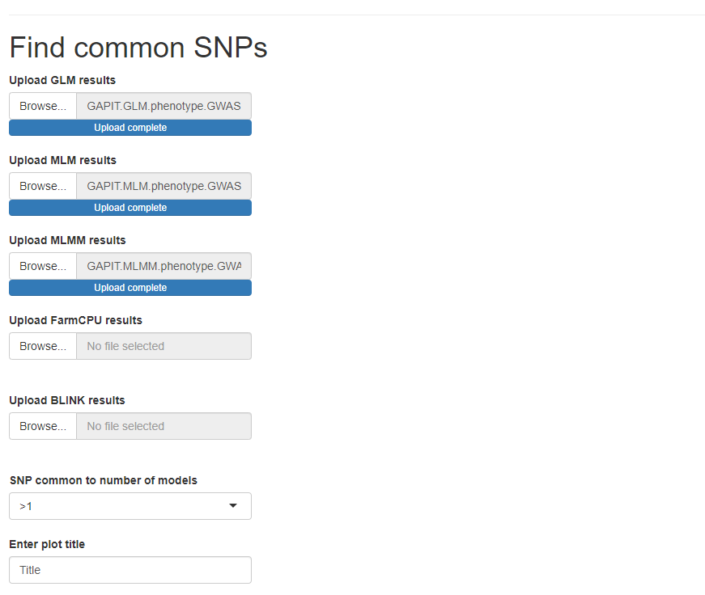

Then select ‘run’ to get the plot.

The output is a kind of Manhattan plot that annotate each model with a different shape, in the output below you can see that there are two SNPs that are common to two models, one on chromosome one and another on chromosome six, in both cases the models are only MLM and MLMM.

The plot is interactive, you can click on a point and it will open the genome browser at the location of the SNP. You can also save the plot.

